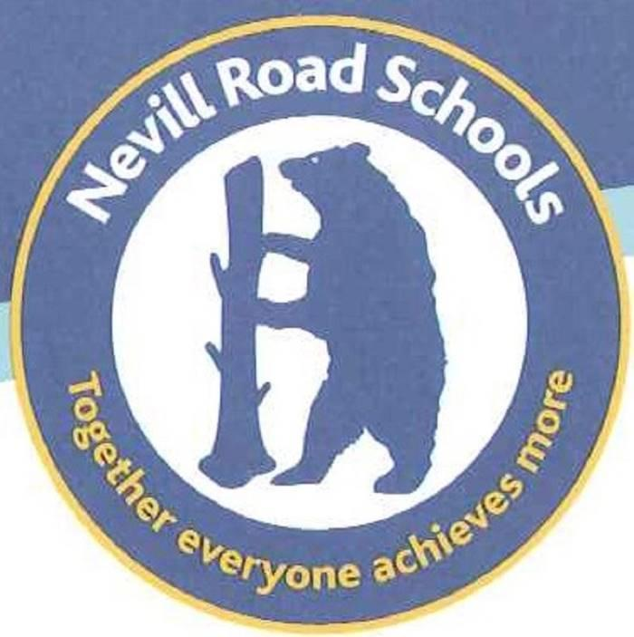
Nevill Road Junior School
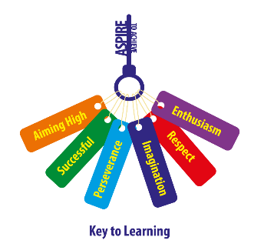
Equality Objectives Development Plan
2022 - 2023

The school’s current Equality Objectives are:-
The school monitors and reviews its equality objectives in consultation with parents, pupils, staff and members of the local community.
1. To develop our Enhanced Curriculum in order to provide opportunities for all.
2. To integrate the Protected Characteristics within the Curriculum.
3. To continue to develop a broad and balanced curriculum that is accessible for all.
4. To raise attainment in reading, writing and maths for specific, identified groups and individual children.

Equality Objective | Actions and Implementation | Timeframe | Impact
1. To develop our Enhanced Curriculum in order to provide opportunities for all. | A wider range of clubs are available to encourage all children to participate.  To monitor attendance and equity amongst girls / boys, PP / non PP, SEND, EAL. Identify children who are not attending club and use pupil voice to find out their interests.  Offer ‘free’ clubs that may target specific children to encourage attendance. | Autumn Term 2022  The range of clubs will be reviewed termly to gauge popularity. | All children have access to additional opportunities e.g. school visits, residentials, clubs.
2. To integrate the Protected Characteristics within the Curriculum. | Focus on specific subjects e.g. PSHE, History, Art. Review the curriculum offer to ensure that race, culture, gender balance is addressed.  Displays around school, the website / twitter to reflect the growing diversity of the school community.  Continue to raise awareness of the Protected Characteristics amongst all stakeholders. Bramhall Cluster focus. | 2021 - 2022 | The Curriculum represents a balanced offer and representation of the Protected Characteristics.  The school environment and external view reflects the diversity of the school community.
3. To continue to develop a broad and balanced curriculum that is accessible for all. | Adaptive teaching strategies (including metacognition) are shared and embedded across school.  Teaching and Learning Policy to be reviewed.  Curriculum for All pyramids to be reviewed.  Bramhall Cluster work with Neala Campling from the Ethnic Diversity Team.  RSHE Curriculum and ensuring this is accessible for all including SEND / EAL. | 2022 - 2023 | The new teaching and learning policy reflects how the Protected Characteristics are integrated through the curriculum.  SEND provision is of a high quality and the curriculum can be accessed by all.  Staff have a clear understanding of how to support children with additional needs including EAL.  Work with parents to shape the RSHE curriculum to ensure inclusion.

4. To raise attainment in reading, writing and maths for specific, identified groups and individual children. | Regularly monitoring of children’s progress through book looks, termly data captures and pupil voice.  To improve the provision for children who have EAL by upskilling staff.  Monitor SEND provision, PPG Strategy and the impact this has upon learning outcomes.  Awareness of gender specific areas e.g. SEND / girls.Analysis of data 2022 shows that there is a gap in attainment for pupils with SEND and girls.  Jo Gray support for reading and Phonics training for all staff. | 2022 2023 | See improved progress for these cohorts of children.  Attainment gaps are reduced and evidence of progress can be seen. e.g. standardised scores and books.

